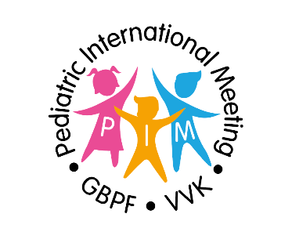
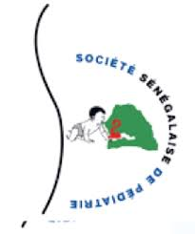

PIM 2023
GBPF - VVK - SOSEPED

TRAVEL ITINERARY

WEDNESDAY 8 FEBRUARY
09:00 Meet & greet at Brussels Airport
12:10 Departure of flight SN 203 to Dakar (Senegal)
17:25 Arrival of flight SN 203 at Dakar International Airport and transfer to the hotel
EVENING Check-in at Lamantin Beach and buffet dinner at the hotel

THURSDAY 9 FEBRUARY
Breakfast at the hotel
Morning Scientific Program : pediatrics in Belgium: how to proceed.
NOON Buffet lunch at the hotel
AFTERNOON Scientific program: Visit of Hospital for sick children Diamniadio
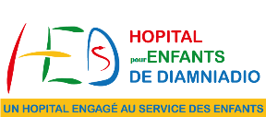
EVENING aperitif and BBQ dinner

FRIDAY 10 FEBRUARY
Breakfast at the hotel
08:30 - 09:00 Registration - pick-up your badge
09:00 - 10:30 Scientific program: Focus on Nutrition
10:30 - 11:00 Coffee break
11:00 - 11:30 Scientific program: Focus on Nutrition
13:00 - 15:00 Lunch break - buffet lunch at the hotel
15:00 - 18:00 Scientific program: Focus on Infections and Imported Diseases
EVENING Gala evening

SATURDAY 11 FEBRUARY
Breakfast at the hotel
08:30 - 10:30 Scientific program: Focus on the organization of Health Care
10:30 - 11:00 Coffee break
11:00 - 12:30 Scientific program: Focus on the organization of Health Care
NOON Buffet lunch at the hotel
AFTERNOON: visit L’île de Gorée (included in congress registration cost)
EVENING Dinner
Departure to Dakar International Airport for flight SN 202 back to Belgium
Check-in for your flight
22:55 Departure of flight SN 202 to Belgium

SUNDAY 12 FEBRUARY
05:50 Arrival of flight SN 202 at Brussels Airport

